THE PRESBYTERIAN PRESS
The monthly newsletter of West Point Presbyterian Church
January 2026

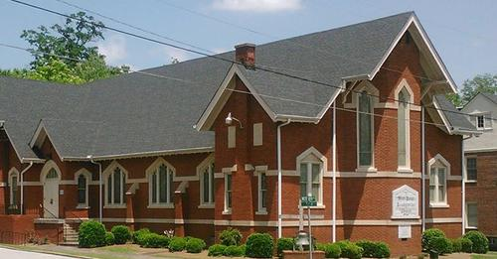
EST. 1837

WELCOME: Grace and peace to you in the name of Jesus Christ.
At WPPC, we are Seeking, Serving, and Sharing…
Seeking…to Nurture Lifelong Christian Disciples.
Serving…the Congregation, Community & World in the Name of Jesus Christ.
Sharing…God’s Love in the Reformed Tradition

West Point Presbyterian Church1002 5thAvenue West Point, Georgia 31833 Phone 706.443.2260
wppc@knology.net
www.westpointpresbyterian.com
www.facebook.com/westpointprez
www.twitter.com/WestPointPresb1





January 2026 |  |  |  |  | West Point Presbyterian Church Calendar
Liturgist-Debbie Von Hollen |  |  |  |  | Head Usher-
3rd Sunday Host -Heath Family
Sunday | Monday | Tuesday | Wednesday | Thursday |  | Friday | Saturday
 |  |  |  | 1 |  | 2  LEO 8am | 3
4  Unity @WPPC 10:30 | 5 | 6 | 7  Lions Club | 8 |  | 9  LEO 8 am | 10
11 | 12 | 13 | 14 | 15 |  | 16  LEO 8 am | 17
18  3rd Sunday and Session | 19 | 20 | 21  Lions Club | 22 |  | 23  LEO 8 am | 24
25 | 26 | 27 | 28 | 29 |  | 30  LEO 8 am | 31


By Rev Jerry Ledbetter…
“And He who was seated on the throne said, “Behold, I am making all things new”. Also, He said, “write this down, for these words are trustworthy and true.” (Revelation 21:5)”
The turning of the calendar often awakens both hope and regret. We remember promises kept and broken, joys celebrated and losses endured. The New Year invites us to imagine change – but Scripture grounds that hope not in our resolutions, but in God’s reign.
In Revelation 21, God speaks from the throne. This is not a suggestion or a wish; it is a sovereign declaration. “I am making all things new.” The verb is present and ongoing. Renewal is not merely future-it is already underway, moving toward its glorious completion when Christ restores all things.
This promise reminds us that God does not simply patch what is broken. He recreates. He does not discard His people or His world; He redeems them. The scars of the past year - sin confessed, grief endured, faith tested-are not wasted. In the hands of the Redeemer, they become part of His renewing work.
As we step into a New Year, this verse calls us to live forward-facing lives. We repent honestly, hope boldly, and trust deeply. The same God who began a good work in you is faithful to complete it (Philippians 1:6). Your story is not defined by last year’s failures, nor is it limited by your present weaknesses. It is held by the One who makes all things new.
And notice the final command: “Write this down.” God knows we forget. He anchors our hope in words that are “trustworthy and true.” When the year brings uncertainty, return to this promise. When renewal feels slow, remember who sits on the throne.

~Jerry

We read Children’s bible stories and we do bible related colorings, and crafts, and play bible games.
Sunday school 10:00 am-10:50 am Children’s Church 11:00 am – 12:00 pm

The adult class gathers for prayer time at 10:00 am and head to Sunday School at 10:15.
Dan Bass facilitates the class in the Stanley Room. We are working on a study of Elijah.
Church Life Events


Our next unity service with First Baptist of West Point is January 4th. We will meet at WPPC @ 10:30.

 January18th is our next Session Meeting.


Monday through Thursday, 9:00 am to noon, Eastern time.
706-443-2260


West Point Presbyterian Church and First Baptist Church of West Point Supper Club NEWS!

Our Supper Club for January will be on Saturday, the 24th @12:30 EST at Mamas Pizza.
The address is 2170 West Point Rd #6, LaGrange, GA 30240

Please let Lori know if you and your family plan to come and how many of you are coming.
Lori Heath (706) 302-4413, a text would be much appreciated.
Thank you



Christian Women’s Group
Open to all who wish to attend. Please come and join us as we work towards combined ministries to serve our communities.
We all enjoyed a cookie swap and fellowship time December 7th, 2025 at First Babtist Church of West Point.
LaChelle reviewed all that we had accomplished/helped in 2025 and the awesome impact we had on our community. Now this is not just what we women accomplished, but what our Churches combined did, we just spearheaded things. It’s amazing the impact we can make in our community.
Our next meeting will be the 1st Sunday of January, the 4th at 5:00 p.m. at West Point Presbyterian Church, in Davis Hall. We will be discussing what projects we want to work on for the first 3 quarters of 2026. Do we want to work towards the same things we did in 2025, or change it up? We are also looking to continuing to meet on Sunday afternoons/evenings, hoping to open this committee up to more women.
Bring your ideas.




If you are hesitant about volunteering as host/hostess, please be assured it’s easy. We even have a cheat sheet. Also, don’t hesitate to partner with someone. Makes for ½ the work and twice the fun. Our next Covered Dish Lunch will be on January 18th; our Hosts will be The Heath Family.


Liturgist
Do you like help with the service? Please add your name to the Liturgist sheet in the Narthex.
Our Liturgist for the month of January is Debbie Von Hollen.

If you would like to bring flowers for our worship service, please let the Church office know. These flowers can be from anywhere! You are responsible for arranging the flowers and putting them in containers, and placing them in the Sanctuary on Sunday morning by 10:45 am.



Do you like to talk with/greet people? Sign up to be Head Usher for a month. It’s easy and a great way to serve. You can even volunteer to assist the Head Usher a time or two to learn the ropes. Head Usher for January is _____________



Session:
Randy Workman (26),
Dan Bass (26),
LaChelle Jones (27),
Murray Bradley (27),
Robert Heath (28),
Ray Gilbert (28)

Clerk of the Session:
Bill Nixon

Treasurer: Ray Gilbert

Senior Pastor
Rev. Gerald (Jerry) Ledbetter

Organist Emeritus
Mr. Austin P. Cook, III

Music Director
Michael Ledbetter

Organist
Randall Smith

PEEP’s Director
Terri Workman

WE PROUDLY SUPPORT

Website: nhct.org Phone 706.643.7529 Box Office Phone 706.518.6234
Address: 411 West 8th St P.O. Box 131 West Point, GA 31833


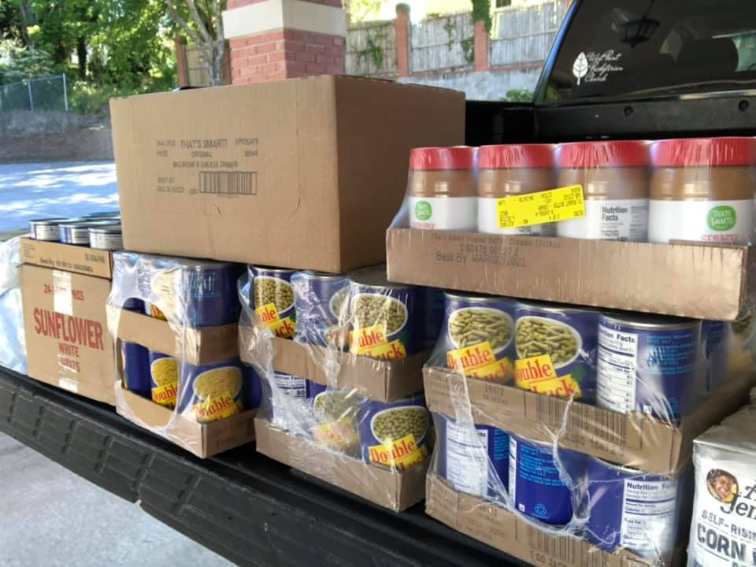

Our P.E.E.P.’s use their pennies for Jesus money to buy food for our little free pantry, won’t you consider helping them?

Pastor Jerry does a weekly outreach, we call it LEO, (Law Enforcement Outreach), on Fridays at 8 am. If you would like to get involved see Jerry.
We support all Law Enforcement Agencies as well as Fire and EMS!

 Thornwell began as a dream in the heart of a young Presbyterian minister, William Plumer Jacobs of First Presbyterian Church in Clinton, SC.



Foundational principles
We at the Fuller Center for Housing believe that: We are part of a God movement, and movements don’t just stop. We have been called to this housing ministry; we didn’t just stumble into it. We are unashamedly Christian, and enthusiastically ecumenical. We aren’t a church but we are a servant of the Church. We are faith-driven, knowing that after we’ve done all we can do the Lord will help finish the job — something that requires us to stretch beyond our rational reach. We are a grass-roots ministry, recognizing that the real work happens on the ground in communities around the world through our covenant partners — so a large, overseeing bureaucracy isn’t needed. We try to follow the teachings of the Bible and believe that it says that we shouldn’t charge interest of the poor, so we don’t. Government has a role in our work in helping set the stage, but that we shouldn’t look to it as a means to fund the building of homes.

A knock at the door might not seem like a big deal to many of us. But, to a homebound senior, it could signal the arrival of the only person they might see all day or all week long. It brings hope. It brings health. It brings the nutrition and care that will completely make their day. A knock from Meals on Wheels can even save lives.
THE POWER OF A KNOCK TRANSFORMS LIVES.

